**Index**

|  |  |  |
| --- | --- | --- |
| **Sr. No.** | **Contents** | **Page No.** |
| **1** | **Annexure I– Micro Project Proposal** | 2-3 |
| 1.Aims/Benefits of the Micro-Project | 2 |
| 2. Course Outcome Addressed | 2 |
| 3.Proposed Methodology | 2 |
| 4. Action Plan | 2-3 |
| 5. Resources Required | 3 |
| 6. Name of student with roll no | 3 |
| **2** | **Annexure II – Micro Project Report** | **4-16** |
| 1.Rationale | 4 |
| 2.Aims/Benefits of the Micro-Project | 4 |
| 3.Course Outcome Achieve | 4 |
| 4. Literature Review | 4-6 |
| 5.Actual Methodology Followed | 6-15 |
| 6.Actual Resources Used | 15 |
| 7. Applications of this Micro-Project | 16 |

**Annexure I**

**Micro Project Proposal**

**Movie Review System**

**1. Aims/Benefits of the Micro-Project:**

The aim is to make a working front-end website and .

**2. Course Outcome Addressed:**

a. Use operating system tools to perform various functions

b. Applications of different operating system based on their functionality.

**3. Proposed Methodology:**

In operating system the work of different operating systems plays a vital role as most the operating systems with different functionalities can be very efficient in the respective work field.

The operating systems have 7 different types and based on these types they are used today we will learn about different operating system and their functionalities.

**4. Action Plan**:

|  |  |  |  |  |
| --- | --- | --- | --- | --- |
| **Sr.**  **No.** | **Details of Activity** | **Planned**  **Start date** | **Planned**  **Finish date** | **Name of Responsible Team Members** |
| 1 | Search the topic of project | 23/08/2022  3:30 – 5:30 PM | 30/08/2022  3:30 – 5:30 PM | Sanket Shivaji Khedkar |
| 2 | Search the information about operating system | 30/08/2022  3:30 – 5:30 PM | 06/09/2022  3:30 – 5:30 PM |
| 3 | Find the list of types of operating system | 13/09/2022  3:30 – 5:30 PM | 13/10/2022  3:30 – 5:30 PM |
| 4 | Find the information of different types of OS | 20/09/2022  3:30 – 5:30 PM | 20/09/2022  3:30 – 5:30 PM |
| 5 | Disadvantages and Advantages of types | 27/09/2022  3:30 – 5:30 PM | 04/10/2022  3:30 – 5:30 PM |
| 6 | Collecting the different images of types of OS | 04/11/2022  3:30 – 5:30 PM | 11/10/2022  3:30 – 5:30 PM |
| 7 | Insert all the collected information | 11/10/2022  3:30 – 5:30 PM | 12/11/2022  3:30 – 5:30 PM |
| 8 | Finalizing Project with its report | 15/11/2022  3:30 – 5:30 PM | 06/12/2022  3:30 – 5:30 PM |

**5. Resources Required:**

|  |  |  |  |  |
| --- | --- | --- | --- | --- |
| **Sr.No.** | **Name of resource / material** | **Specification** | **Quantity** | **Remarks** |
| 1 | Computer | WINDOWS 7, 2GB RAM, 160GB HDD | 1 |  |
| 2 | Operating System | WINDOWS 7 | 1 |  |
| 3 | Browser | Chrome | 1 |  |

**6. Names of Team Member with Roll No.:**

|  |  |  |  |
| --- | --- | --- | --- |
| **Sr. No.** | **Enrollment No.** | **Name of Team Member** | **Roll No.** |
| 1 | 2010950092 | Sanket Shivaji Khedkar | 17 |

**Mr. Chavan A.Y**

**Name and Signature of the Teacher**

**Annexure – II**

**Micro-Project Report**

**Report on features of types of Operating System**

**1. Rationale:**

An operating system is basically a system program that controls the execution of application programs and acts as an interface between applications and the computer hardware. It manages the computer system resources to be used in an efficient manner. This course enables to learn internal functioning of operating system for given applications. This course is also a prerequisite for the group of course included in Cloud Infrastructure Maintenances Elective group.

**2. Aims/Benefits of the Micro-Project:**

The aims of scheduling are to: Make sure the CPU is working as hard and as efficiently as possible. Make sure the resources such as printing are used as efficiently as possible. Ensure that users on a network think they are the only ones on the system.

**3. Course Outcomes Achieved:**

a. Use operating system tools to perform various functions

b. Applications of different operating system based on their functionality.

**4. Literature Review:**

The operating system plays a major role in managing processes arriving in the form of multiple queues. The arrival of a process is random along with their different categories and types. All these require scheduling algorithms to work over real time environment with special reference to task, control and efficiency. Many Researchers have introduced various CPU scheduling algorithms from time to time.

**5. Actual Methodology Followed:**

**#about.html**

<html>

<div>

<head>

<link rel="icon" href="D:\js programs\New folder\images\banner.png" type="image/icon type">

<link rel="stylesheet" type="text/css" href="aboutstyle.css"></head></div>

<body background="D:\js programs\New folder\images\movie.jfif"><br/>

<script type="text/javascript">

function home(){

window.location.href="file:///D:/js%20programs/New%20folder/grid.html"

}

</script>

<div id="navlist"><center>

<nav>

<ul>

<a href="#"> Home </a>

<a href="#"> About </a>

<a href="#"> Contact </a>

<a href="#"> Terms of use </a>

<a href="#"> Join Us </a>

</ul>

</nav>

</div>

</div>

<div class="main"><center> <font color=white><h4>

Fandango is the ultimate digital network for all things movies and TV, serving more than 50 million unique visitors per month, according to comScore, with best-in-class movie and TV information, movie ticketing, trailers and original video, and home entertainment. Its portfolio features leading online ticketers Fandango, MovieTickets.com and Flixster; world-renowned entertainment review site Rotten Tomatoes; and Movieclips, the #1 movie trailers and content channel on YouTube. Fandango's on-demand streaming service, Vudu, offers over 200,000 new release and catalog movies and next-day TV shows to more than 200 million connected, over-the-top (OTT) and mobile devices.</h4>

<img src="D:\js programs\New folder\images\wall e.jfif" alt="custom_html_banner" width= "50%" height="480" name="ChangeBanner"><br>

<br><input type="button" name="start" value="Start" width="250px" height="250px" onclick="home()">

</center>

</div>

</body>

</body>

</html>

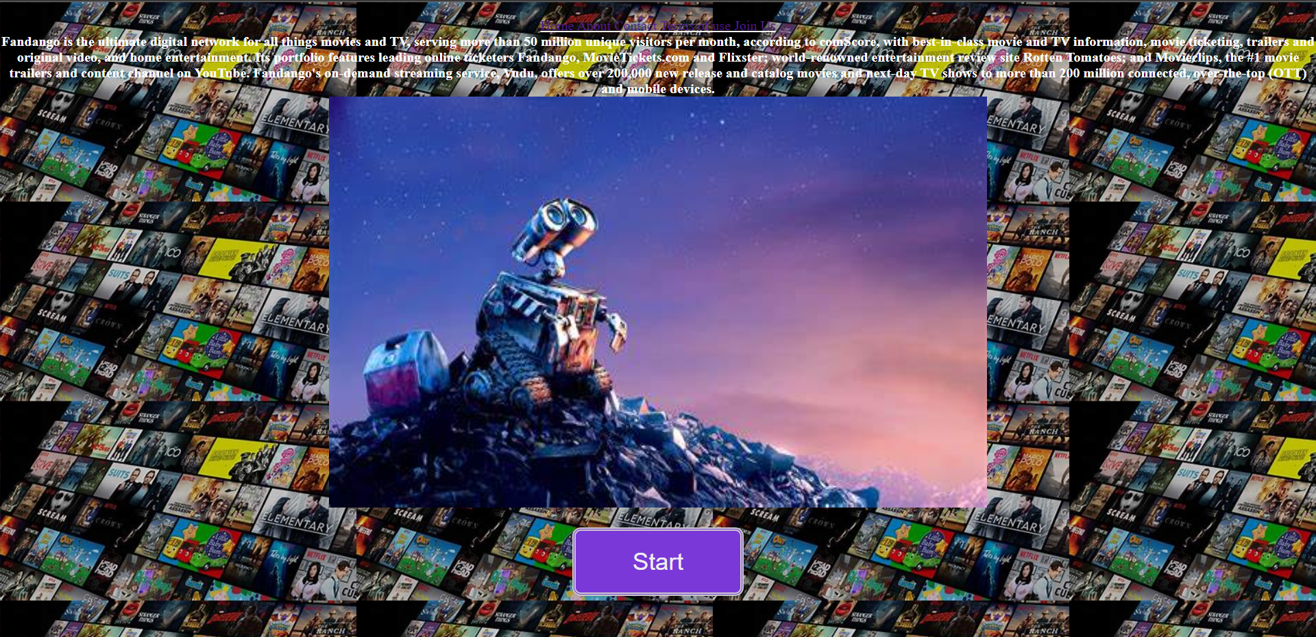

**#Main.html**

<!DOCTYPE html>

<html>

<head>

<meta charset="utf-8">

<meta name="viewport" content="width=device-width, initial-scale=1">

<title>Movie Review</title>

<link rel="stylesheet" type="text/css" href="sty.css">

<nav>Login</nav>

</head>

<body>

<nav>

<input type="button" name="Login" id="check1" onclick="home()">

<input type="radio" name="photos" id="check2">

<input type="radio" name="photos" id="check3">

<input type="radio" name="photos" id="check4">

</nav>

<div class="container">

<h1>Movie review</h1>

<div class="top-content">

<h3>movies</h3>

<label for="check1">Login</label>

<label for="check2">About us</label>

<label for="check3">Upcoming movies</label>

<label for="check4">top this week</label>

</div>

<div class="us">

<h2>Read everything under the sun</h2>

<p>This is your source for movie reviews and movie ratings to help maximize your movie-going-experience. Our easy to use movie reviews and movie ratings are based on scores and opinions from respected movie critics, family advocacy groups and movie fans like you. Whether it’s a family movie outing, first date or girls’ night out, our movie reviews will help you find the perfect movie for any occasion.</p>

</div>

<div class="slideshow-container">

<div class="mySlides fade">

<div class="numbertext">1 / 3</div>

<img src="D:\js programs\New folder\images\OIP.jpeg" style="width:100%">

<div class="text"></div>

</div>

<div class="mySlides fade">

<div class="numbertext">2 / 3</div>

<img src="D:\js programs\New folder\images\Black-Panther.jpeg"style="width:100%">

<div class="text"></div>

</div>

<div class="mySlides fade">

<div class="numbertext">3 / 3</div>

<img src="D:\js programs\New folder\images\1899.jpeg" style="width:100%">

<div class="text"></div>

</div>

<!-- Next and previous buttons -->

<a class="prev" onclick="plusSlides(-1)">&#10094;</a>

<a class="next" onclick="plusSlides(1)">&#10095;</a>

</div>

<br>

<div style="text-align:center">

<span class="dot" onclick="currentSlide(1)"></span>

<span class="dot" onclick="currentSlide(2)"></span>

<span class="dot" onclick="currentSlide(3)"></span>

</div>

<div class="movie">

<div class="select">

<img src="C:\Users\SANKET\Downloads\8 miles.jpeg"alt="movie">

<p>8 Mile is a 2002 American drama film written by Scott Silver and directed by Curtis Hanson. It stars Eminem in his film debut, alongside Mekhi Phifer, Brittany Murphy, Michael Shannon, Anthony Mackie, and Kim Basinger.</p>

<a href="https://www.imdb.com/title/tt0298203/reviews">read more</a>

</div>

<div class="select 1">

<img src=C:\Users\SANKET\Downloads\avengers.jpeg alt="Latest">

<p>The Avengers and their allies must be willing to sacrifice all in an attempt to defeat the powerful Thanos before his blitz of devastation and ruin puts an end to the universe.</p>

<a href="https://www.imdb.com/title/tt4154756/reviews/?ref_=tt_ql_urv">read more</a>

</div>

<div class="select 2">

<img src=C:\Users\SANKET\Downloads\cpfa.jpeg alt="Upcoming">

<p>Steve Rogers, a rejected military soldier, transforms into Captain America after taking a dose of a "Super-Soldier serum". But being Captain America comes at a price as he attempts to take down a warmonger and a terrorist organization</p>

<a href="https://www.imdb.com/title/tt0458339/reviews/?ref_=tt_ql_urv">read more</a>

<span class="fa fa-star checked"></span>

<span class="fa fa-star checked"></span>

<span class="fa fa-star checked"></span>

<span class="fa fa-star"></span>

<span class="fa fa-star"></span>

</div>

</div>

</div>

<div class="wrapper">

<div class="sidebar">

<div class="profile">

</div>

</div>

</div>

<div class="footer">

<hr>

</div>

<script type="text/javascript">

function home()

{

let url ="web.html";

window.open(url);

}

let slideIndex = 0;

showSlides();

function showSlides() {

let i;

let slides = document.getElementsByClassName("mySlides");

for (i = 0; i < slides.length; i++) {

slides[i].style.display = "none";

}

slideIndex++;

if (slideIndex > slides.length) {slideIndex = 1}

slides[slideIndex-1].style.display = "block";

setTimeout(showSlides, 5000); // Change image every 2 seconds

}

</script>

</body>

</html>

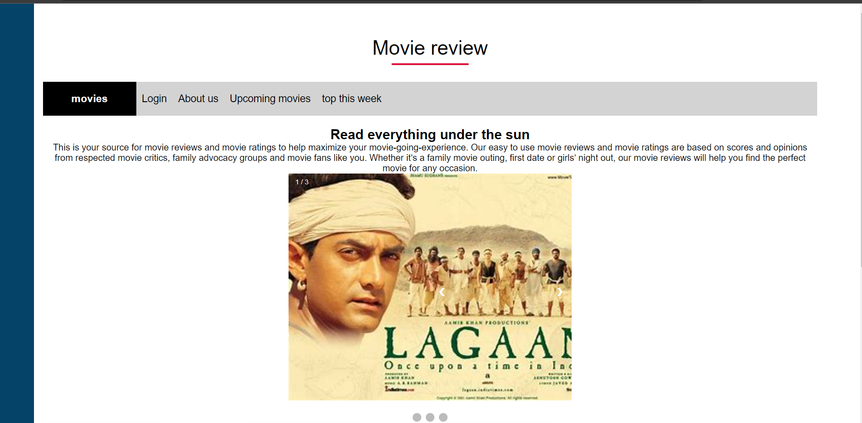

**#Login.html**

<html>

<head>

<meta charset="utf-8">

<title>Sanket Khedkar</title>

</head>

<font color="#A6ACAF" size="5">

<marquee><b><i>Login to continue</i></b></marquee>

</font>

<body background="D:\js programs\New folder\images\wall e.jfif" link="white" alink="black" vlink="#3e3ed4" style="background-color:white;">

<br />

<center>

<article>login in to get access to review comments<br> HTml and css </article><br>

</center>

<font face="cinzel" size="4">

<center>

<form>

<label for="fname">First Name:</label>

<input type="text" id="fname" name="fname"><br>

<label> <b>Password</b> </label>

<input type="password" name="" value=""/required>

<button>Click me</button>

</form>

</center>

</font>

<br /><br /><br /><br />

<br />

<br />

<h1 align="center">

<font color="#e2d604" size="4" >

WELCOME TO LOGIN PAGE<br/>

</font>

START OF A JOURNEY

</h1>

<hr>

<details>My name is Sanket Khedkar i designed this web page using Html and css</details>

<details>this toggle button describes the way we can decide to view or hide the information</details>

</body>

</html>

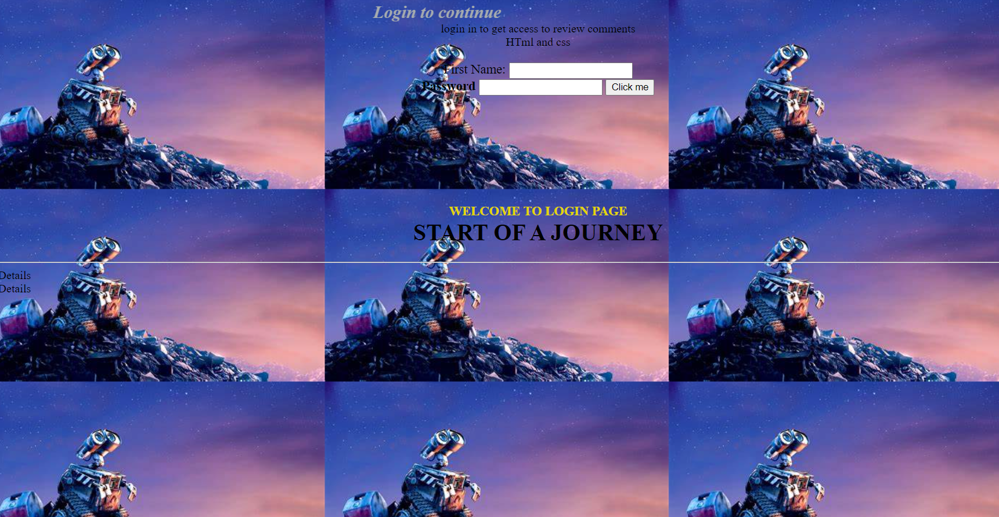

**6. Actual Resources Used:**

|  |  |  |  |  |
| --- | --- | --- | --- | --- |
| **Sr.**  **No.** | **Name of resource / material** | **Specification** | **Quantity** | **Remarks** |
| 1 | Computer | WINDOWS 7,2GB RAM, 160GB HDD | 1 |  |
| 2 | Operating System | WINDOWS 7 | 1 |  |
| 3 | Browser | Chrome | 1 |  |

**7. Skill developed / Learning out of this Micro-Project:**

I learnt from this project the features of different operating systems and their purpose.

**8. Applications of this Micro-Project:**

The different types of operating system are used for different is to provide different services as needed. As most of the OS provide convenience and easy to use interface but some also prefer open source more than GUI to develop some applications and operating system related development.

*********